1.Write a Python program to convert kilometers to miles?

Ans :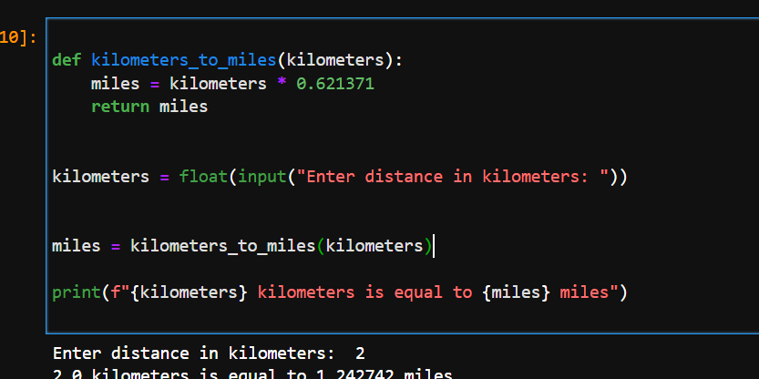

2. Write a Python program to convert Celsius to Fahrenheit?

Ans: 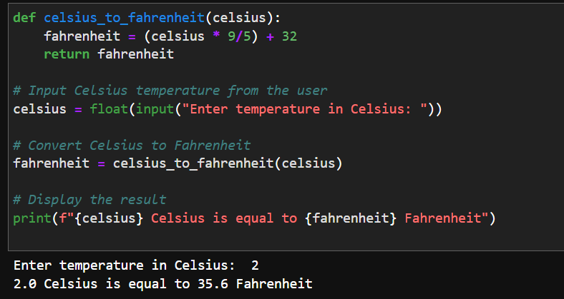

P.T.O

3. Write a Python program to display calendar?

Ans: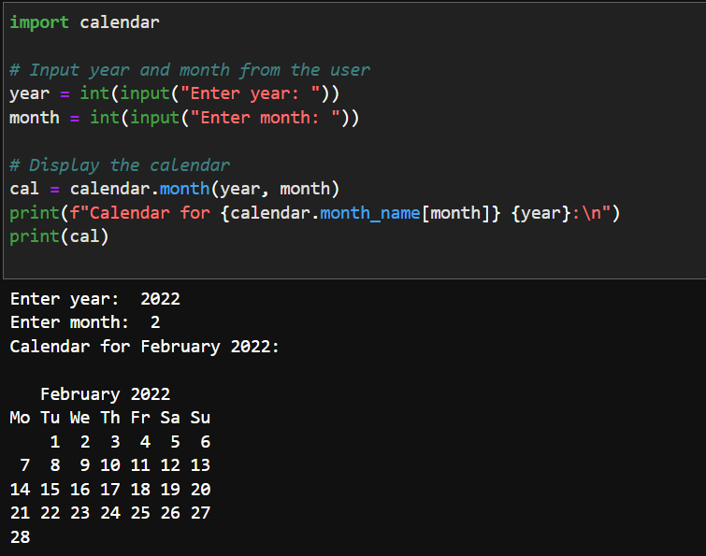

4. Write a Python program to solve quadratic equation?

Ans:

5. Write a Python program to swap two variables without temp variable?

